Project Maker: Courtney Eash
Project Name: Germany Travel Video
Project Type: Video
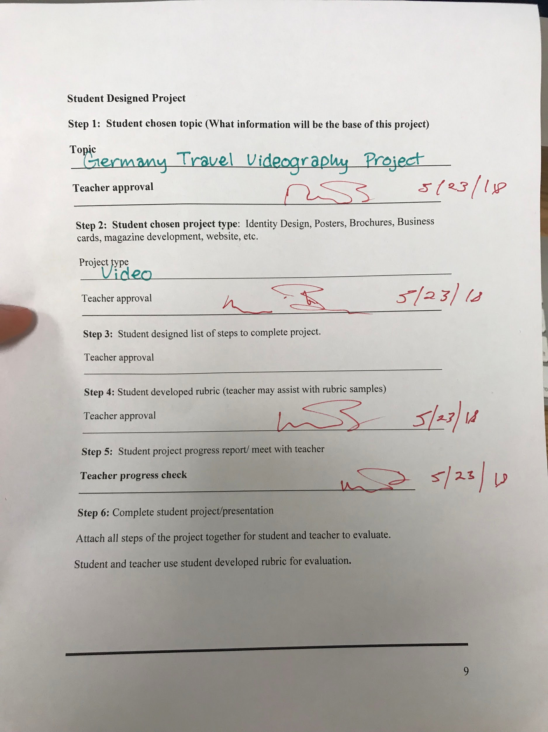

List of Steps:

- Prepare a timeline for capturing videos
- Acquire an appropriate video taking device
- Choose appropriate song
- Edit video into the song
- Make sure the videos are in sequential order
- Check for high resolution and pauses
- Save video in best quality
- Upload video and share

Rubric

 | 4 | 3 | 2 | 1
Preparation
Visually Unique
Capturing a Natural Moment
Permission from those in video
Dedication
Creativity
Quality

